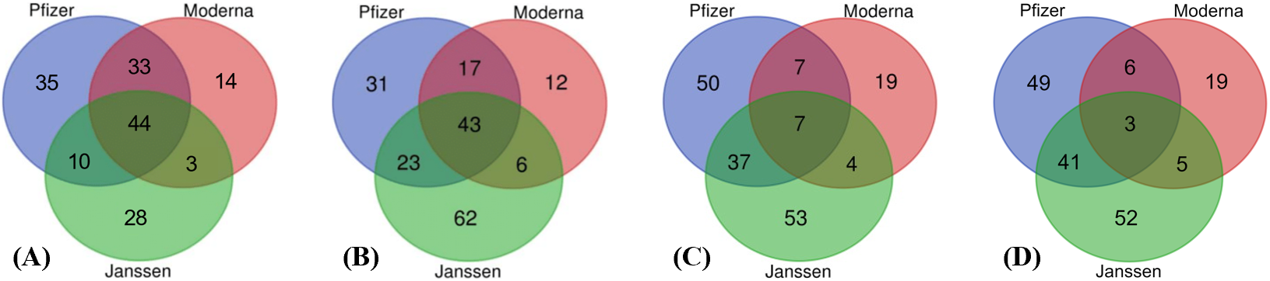

Supplemental Figure 1. Results of statistically enriched AEs obtained at different time points from VAERS for the Pfizer, Moderna, and Janssen vaccines. (A) Data as of April 9, 2021. (B) Data as of May 26, 2021. (C) Data as of October 29, 2021. and (D) Dec 31, 2021. The number of shared AEs appeared to decrease over time with increasing sample sizes.

